**RIPHAH INTERNATIONAL UNIVERSITY, ISLAMABAD**



**Lab 7**

**Bachelors of Computer science – 5th semester**

**Subject:** Operating System Lab

**Submitted to:** Ma’am Kausar Nasreen Khattak

**Submitted by:** Javeria Inam

**Sap Id:** 39977

**Date:** 7th October, 2024



Echo is used for print



mkdir is used for make directory lab1 is the name of directory



rmdir remove the directory lab1 directory is removed



rmdir remove the directory lab1 directory is removed with its content



ls show list its give file and directory lists



Change directory from root toh lab1



Move lab1 directory inti lab directory



Nano,pico,vi ,touch is used for make file .nano make with file1 name



Cat is used to create text file file2 is the name of file2 where we enter text



Cat is used for text file file2 is already exist we copy file2 with new name files



Copy file into directory



Move file1 with newname file2. Change name



Move file2 in directory lab2



Show hidden files

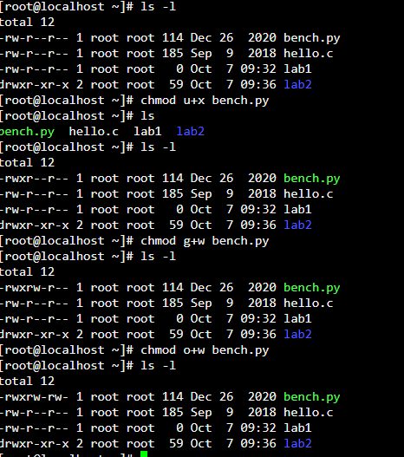

Give permission here read write execute

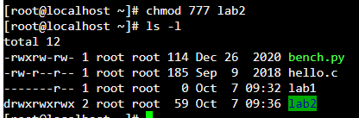

Give all command at a time

**The time of the log entry in the 12-hour format with AM/PM.**

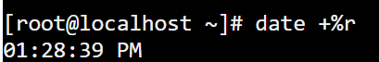

**The date of the log entry in the "Month Day Year" format.**



**OR**

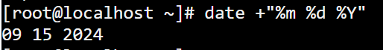

**The full weekday name for the log entry.**



**The numerical representation of the month.**



**The last two digits of the year.**



**24-hour format with only hours and minutes**



**the current year in four-digit format**



**current date in a combined format of numerical day, month, and year and Time**

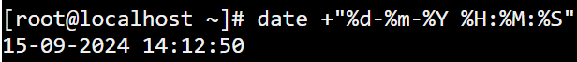

**cal**

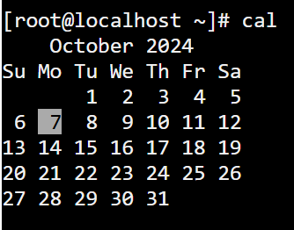

**Yesterday date:**

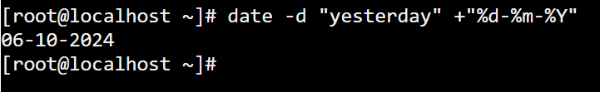

**tomorrow date:**



**10 days ago:**



**Calculator of month December 2024:**

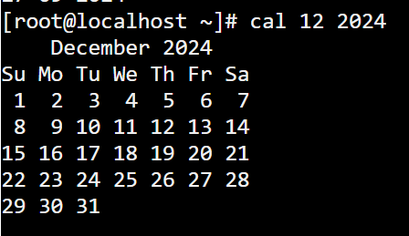

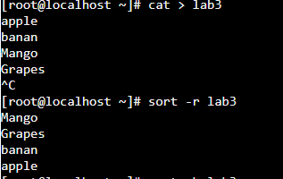

Sort reverse

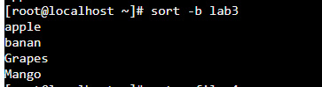

Sort alphebatecialy

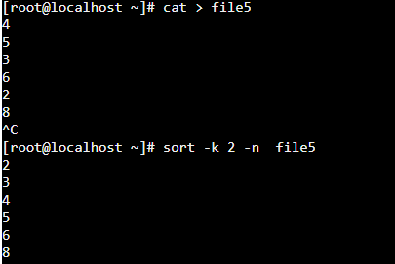

Sort in order